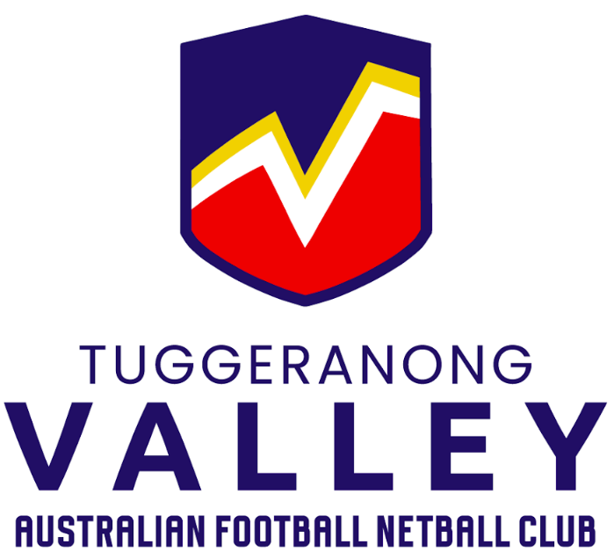
Fundraising Activity
National Multicultural Festival Feb 7-9, 2025

Waste Away is local business that has operated in Canberra for the past 40 years and have been contracted to provide the waste management for the National Multicultural Festival for the past 5 years. This is an annual event run by the ACT Government held in February each year. The event attracts up to 200,000 patrons and exhibitors.
For 2025’s event TVAFNC have teamed up with Waste Away to assist with club fundraising. Waste Away have committed to providing a cash donation to TVAFNC in return for labour at the event. All members are invited to participate. This could be as little as 1 small 4 hour shift or it could be up to 3 eight hour shifts. Please see below table as a guide to donations
The donation will be made at above hourly award rates for hours worked e.g. If there are 10 people who work 3 x 6 hour shifts, the donation to the club will be approximately $6k!
Anyone who participates in the opportunity will be put through an induction and carefully supervised. Despite being classified as ‘volunteers’, the team willl be covered by Waste Away employee insurances.
Please fill in the below table with your details and the hours you are available to work.

Name:

Age (if under 18):

Contact phone:

Waste Away Roster: | *Availability (your preferred shift times)
Fri 7 February – (4pm-2am)

Sat 8 February – (8am-2am)

Sun 9 February – (8am-9pm)

Warm regards,
Daniel Shaw
Director Volunteers
0434536265
Tuggeranong Valley Australian Football and Netball Club


